Ideation Phase
Brainstorm & Idea Prioritization Template

Date | 8 february 2026
Team ID | LTVIP2026TMIDS35897
Project Name | BookNest : where stories nestle
Maximum Marks | 4 Marks

Brainstorm & Idea Prioritization Template:
Step-1: Team Gathering, Collaboration and Select the Problem Statement
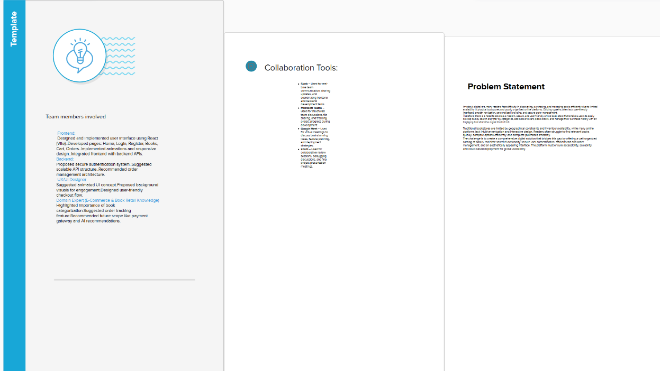
Step-2: Brainstorm, Idea Listing and Grouping
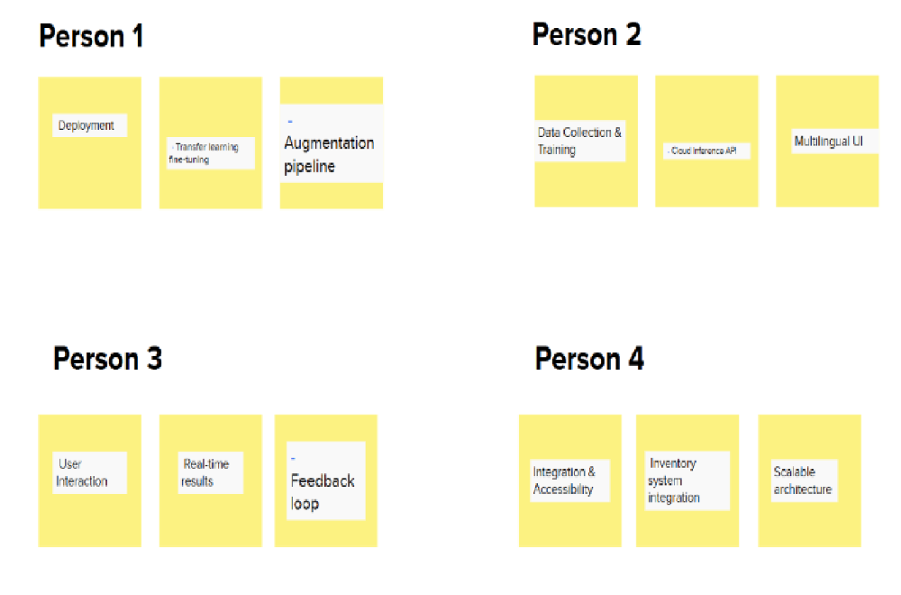
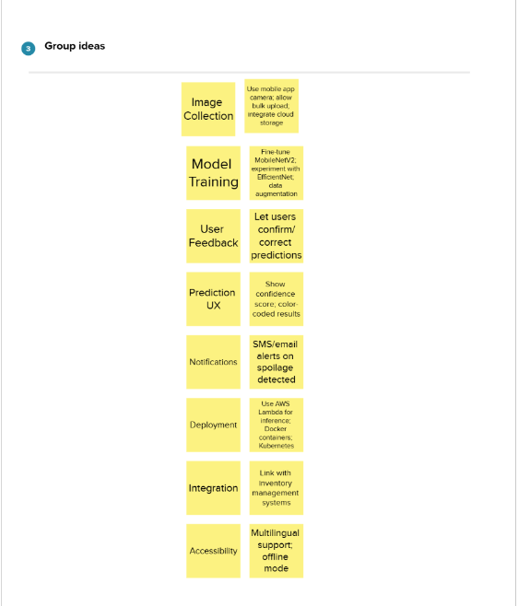

Step-3: Idea Prioritization
